- 
Online Examination System

A Course Project report submitted
in partial fulfillment of requirement for the award of degree

BACHELOR OF TECHNOLOGY
in
SCHOOLOF COMPUTERSCIENCE AND ARTIFICIAL INTELLIGENCE

By
Md.Sameer Ali 2403A52175
Ch.Abhinay 2403A52176
D.Sri Harsha 2403A52177
Ch.Rohith 2403A52178
A.Sai Saketh 2403A52179

Under the guidance of
Mr. Bura Vijay Kumar
Assistant Professor, School of CS&AI.


SR University, Ananthasagar, Warangal, Telangana-506371

CERTIFICATE
This is to certify that the project entitled “Online Examination System” is the bona fide work carried out as part of the Web Technologies and Mobile Programming Course Project for the partial fulfillment of the requirements of the Bachelor of Technology, School of CS&AI, SR University during the academic year 2024–2025 under my guidance and supervision.
Mr. Bura Vijay Kumar (Guide)
Assistant Professor, SR University
Dr. M. Sheshikala
Professor & Head, School of CS&AI
SR University

ACKNOWLEDGEMENT
We express our deep gratitude to our course project guide Mr. Bura Vijay Kumar for his timely guidance and continuous support. We thank Dr. M. Sheshikala, Professor & Head, School of CS&AI, for providing the required academic environment. We also acknowledge the support of all teaching and non‑teaching staff members and our families.

ABSTRACT
The Online Examination System is a robust, web-based platform designed to automate the entire examination lifecycle. It addresses inefficiencies in traditional exam methods by offering secure authentication, flexible exam creation, real-time conduction, automated evaluation, and instant result generation. Unlike conventional systems, it integrates role-based dashboards, scalable architecture, and modern security protocols. Built using HTML, CSS, JavaScript, Node.js, Express.js, and MongoDB, it ensures transparency, usability, and adaptability for academic institutions, corporate training, and certification bodies.
This project demonstrates how full-stack development can be applied to solve real-world academic challenges, while also providing students with hands-on experience in cloud deployment, database modeling, and API security

KEYWORDS
Keywords are critical in academic reports as they capture the essence of the project. For this system, terms such as Web Application, Online Examination, Automation, Node.js, Express.js, MongoDB, JWT Authentication, Timer-based Exams, MCQ Evaluation are used. These keywords reflect the technical foundation and functional scope of the project. They also serve as indexing terms, making the report easily searchable in academic databases. Each keyword represents a core concept: for example, JWT Authentication emphasizes security, while Timer-based Exams highlights exam integrity.

ABOUT THE ORGANIZATION
SR University is a leading innovation‑driven institution located in Warangal, Telangana. The School of CS&AI is known for its strong academic programs, research excellence, and emphasis on practical learning in areas including Web Technologies, Mobile Programming, Cloud Computing, and Artificial Intelligence.

INTRODUCTION
Examinations are a critical component of education, but traditional methods suffer from inefficiency, human error, and logistical challenges. With the rise of digital learning ecosystems, institutions require platforms that are:
- Automated: Reducing manual workload.
- Secure: Protecting exam integrity.
- Scalable: Supporting thousands of concurrent users.
- Transparent: Providing instant feedback and analytics.
The Online Examination System bridges this gap by combining modern web technologies with secure backend services, ensuring smooth exam conduction across diverse environments.

RELATED WORK
Existing tools like Google Forms, Moodle LMS, and ERP exam modules provide online testing functionality but lack customized exam workflows, real-time scoring systems, role-based access, or modern authentication layers. Research emphasizes the need for secure web-based exam platforms with automated marking, scalability, and user-friendly design—all of which are addressed by this project.

PROBLEM STATEMENT
Manual examinations are time-consuming, prone to human error, and inefficient to manage. Storing answer sheets, scoring, and communicating results requires considerable effort. Institutions face challenges such as delayed results, difficulty in tracking performance, data management issues, and lack of transparency. A secure online exam system is required to automate the entire examination workflow.

REQUIREMENT ANALYSIS
Functional Requirements:
• Secure Registration & Login
• Faculty Exam Creation
• Add MCQ Questions
• Timer-based Online Exam
• Auto-Evaluation of MCQs
• Result Dashboard
• Role-Based Access (Student/Faculty/Admin)
Non-Functional Requirements:
• Security (JWT, bcrypt, HTTPS)
- Reliability under concurrent load
- Performance Optimization (API caching, DB indexing)
- Scalability (cloud deployment readiness)
- Responsive UI (mobile-first design)
- Accessibility (WCAG compliance for differently-abled users

RISK ANALYSIS
• Server Downtime
• Unauthorized Access
• High Exam Load
• Weak Passwords
• Database Failure
Mitigation Strategies:
• Data Backups
• Strong Authentication
• Input Validation
• Token-based Security
• Log Monitoring

FEASIBILITY ANALYSIS
Technical Feasibility: Uses open-source tools such as Node.js, Express.js, and MongoDB.
Economic Feasibility: No licensing costs.
Operational Feasibility: Easy to use by students and faculty.
Schedule Feasibility: Modules achievable within course duration.

PROPOSED SOLUTION
The proposed Online Examination System provides a structured and secure method for conducting exams. It includes separate dashboards for students and faculty, automated question handling, real-time test monitoring, and instant scoring. The system enhances efficiency, reduces manual workload, and ensures digital transparency.

SYSTEM ARCHITECTURE
Frontend (HTML/CSS/JS) → Backend (Node.js/Express.js) → Database (MongoDB)
Components:
• User Interface
• Authentication
• Question & Exam Handler
• Evaluation Engine
• Results Module

DATABASE DESIGN
Users(userId, name, email, password, role,lastLogin)
Exams(examId, title, duration,createBy,status)
Questions(questionId, examId, questionText, options, correctAnswer)
Submissions(submissionId, examId, studentId, answers, score,timestamp)

IMPLEMENTATION
Frontend built using HTML, CSS, and JavaScript.
Backend built using Express.js including REST API routes.
MongoDB used for secure data storage.
Authentication handled using JWT and password hashing.

RESULTS
• Smooth exam conduction
• Accurate automatic evaluation
• Fast API response time
• Instant results
• Successful multi-user testing

LEARNING OUTCOME
Through the Online Examination System project, students gained practical skills in full-stack development, including frontend design with HTML, CSS, and JavaScript, and backend implementation using Node.js and Express.js. They learned database modeling with MongoDB, secure authentication using JWT and bcrypt, and the importance of performance optimization. The project also strengthened abilities in testing, debugging, and deployment on cloud platforms. Beyond technical expertise, students developed collaboration, problem-solving, and project management skills, preparing them for real-world software engineering challenges.

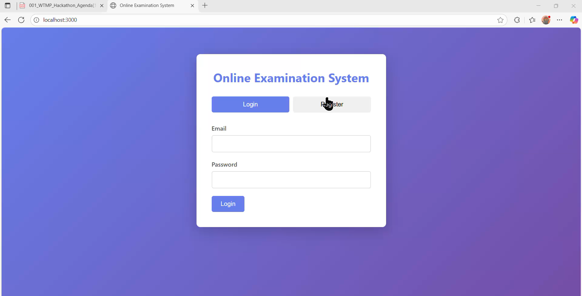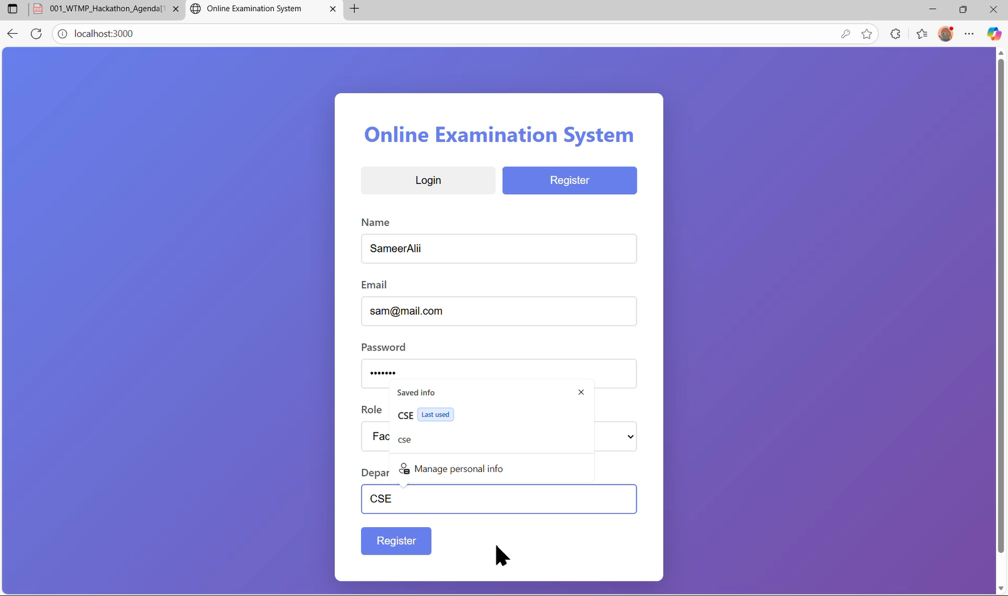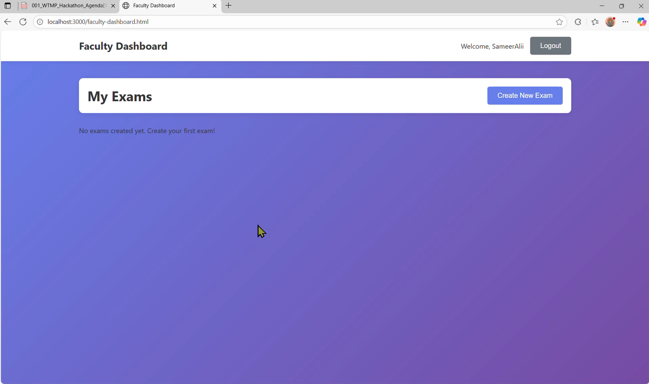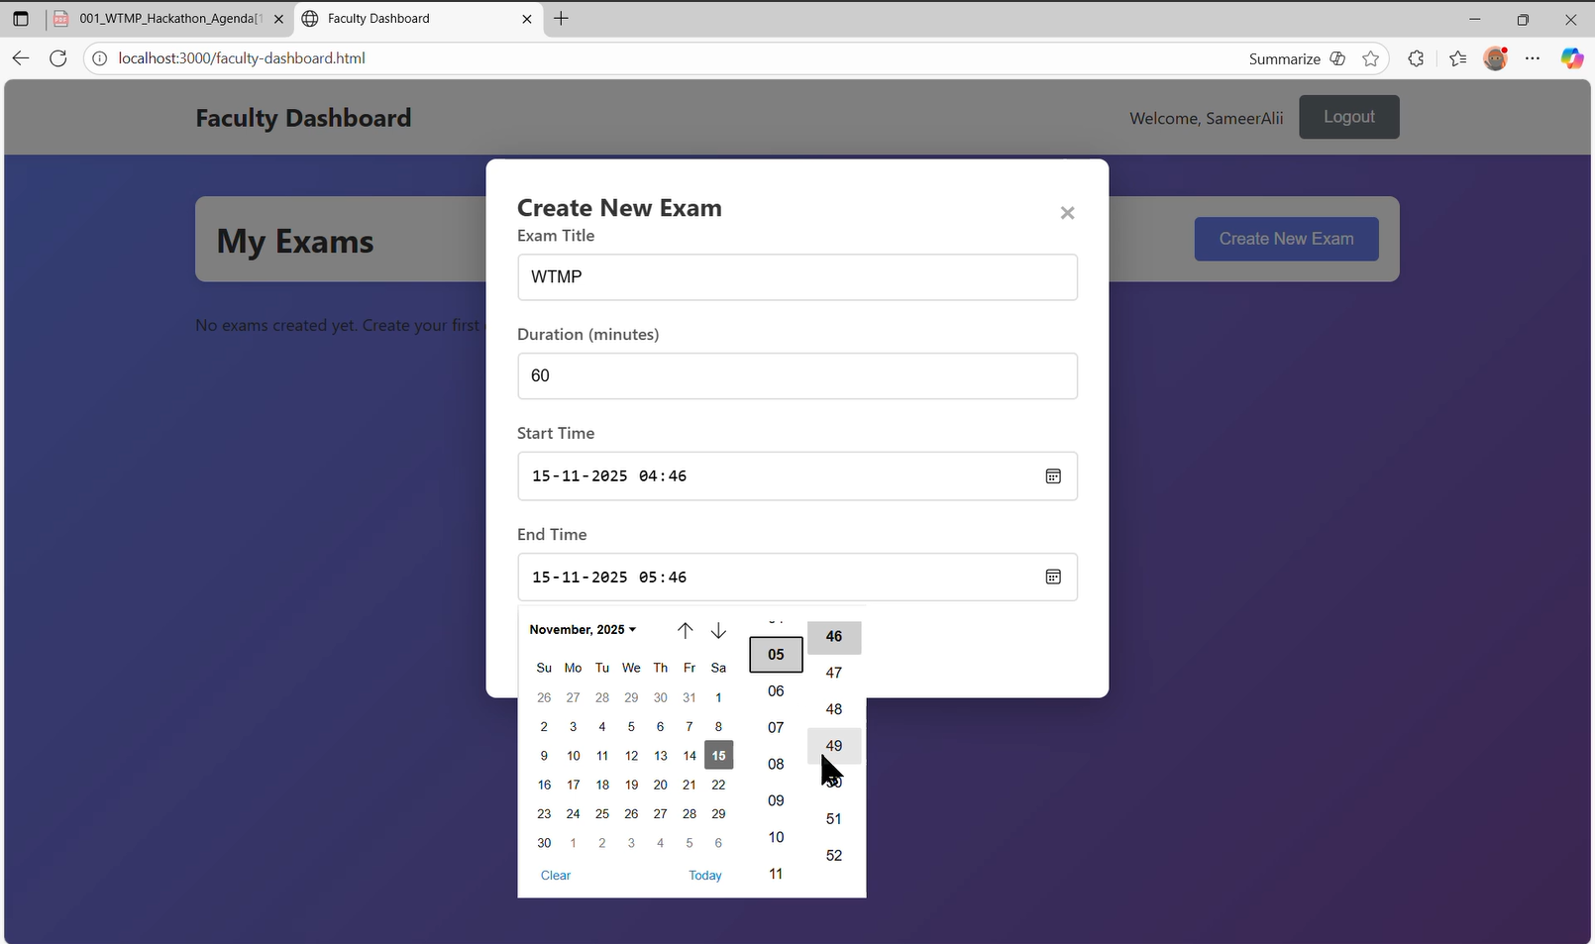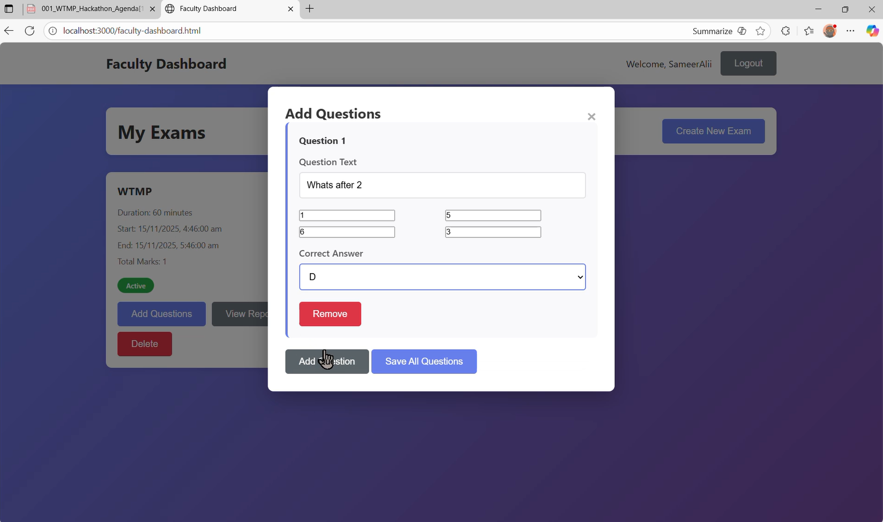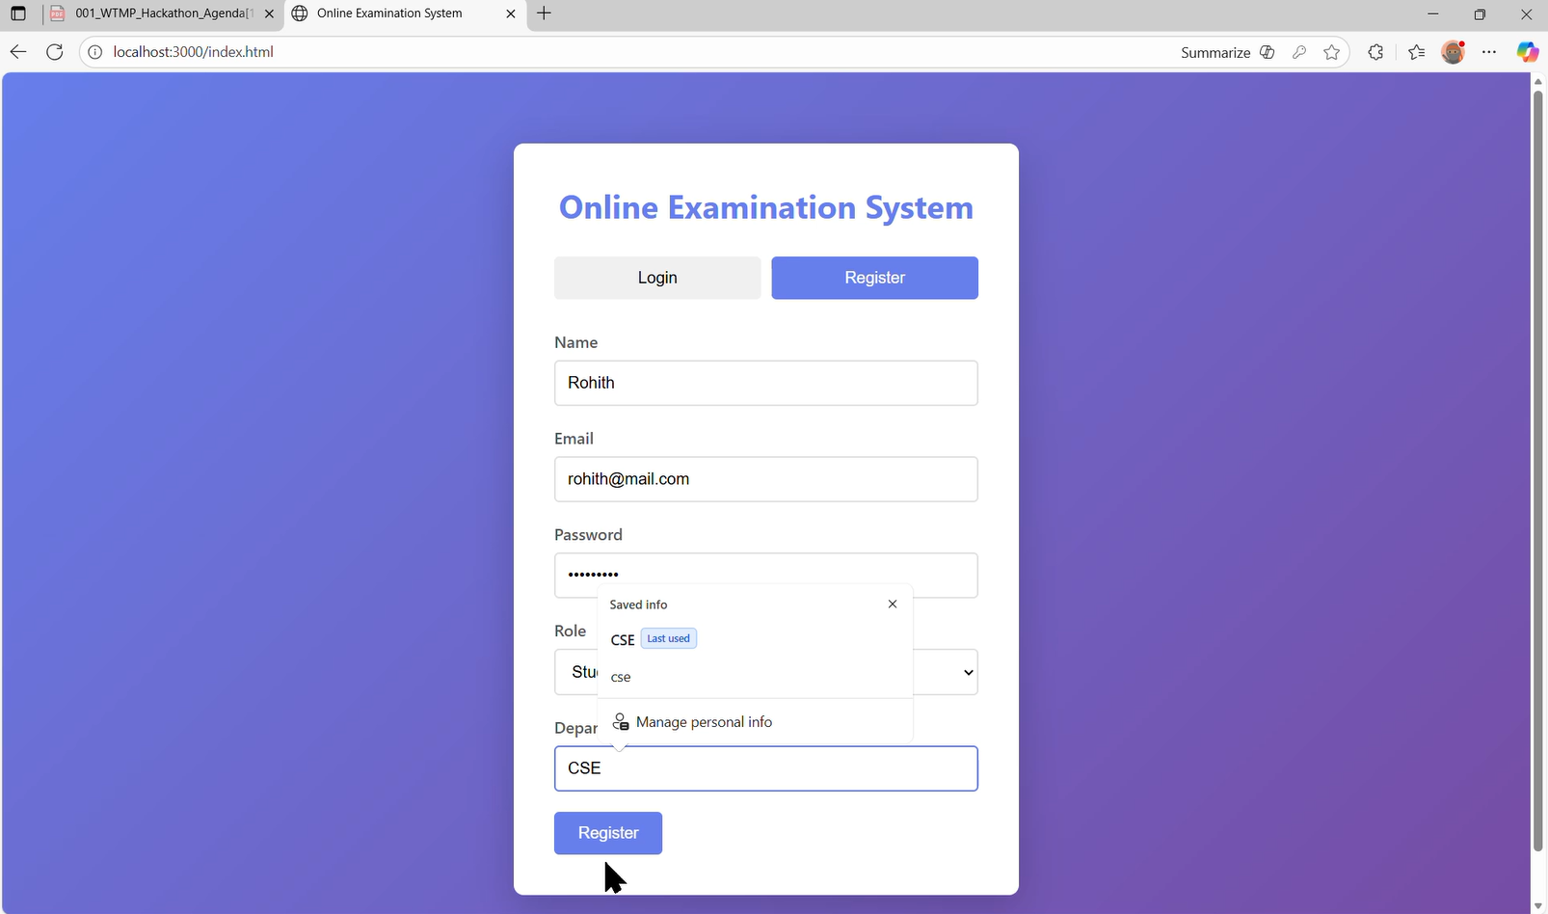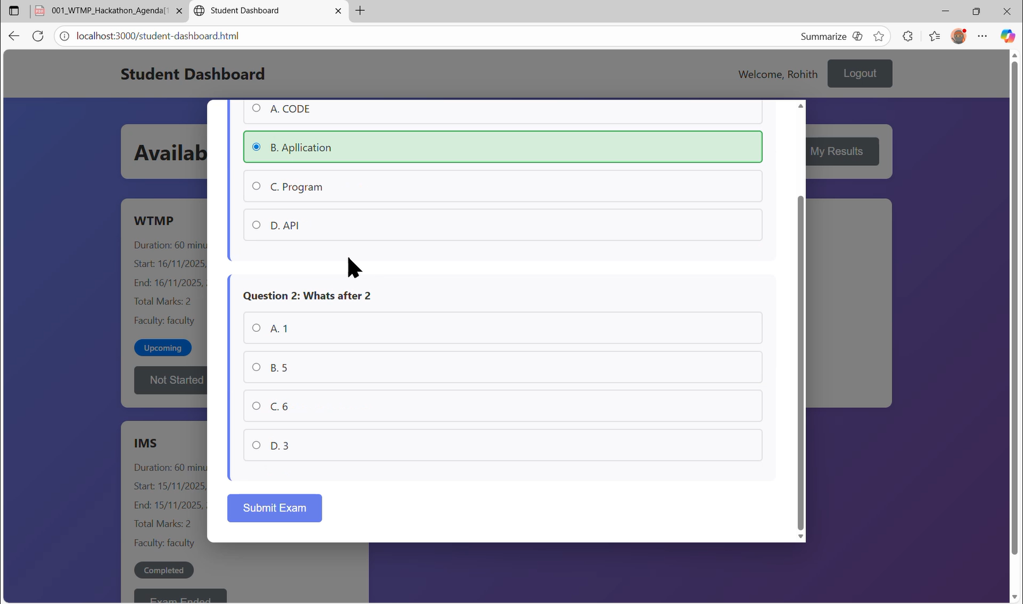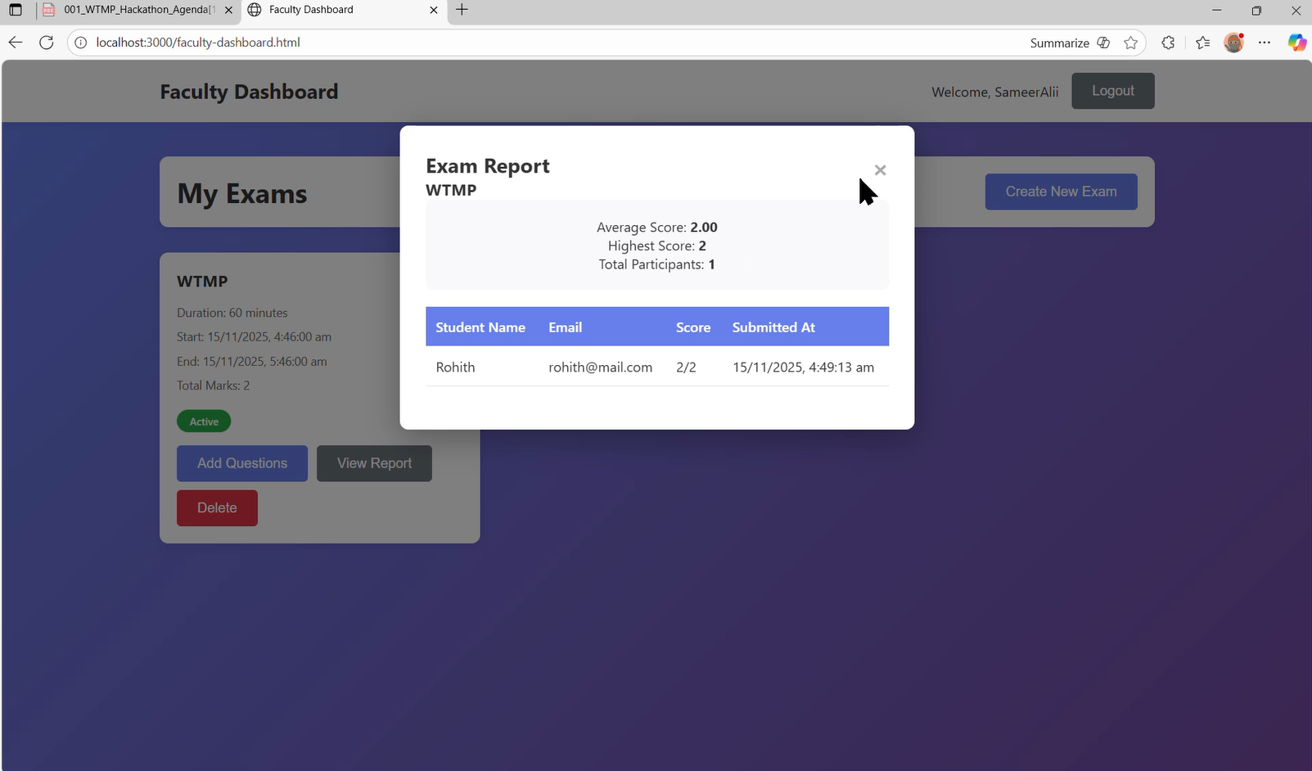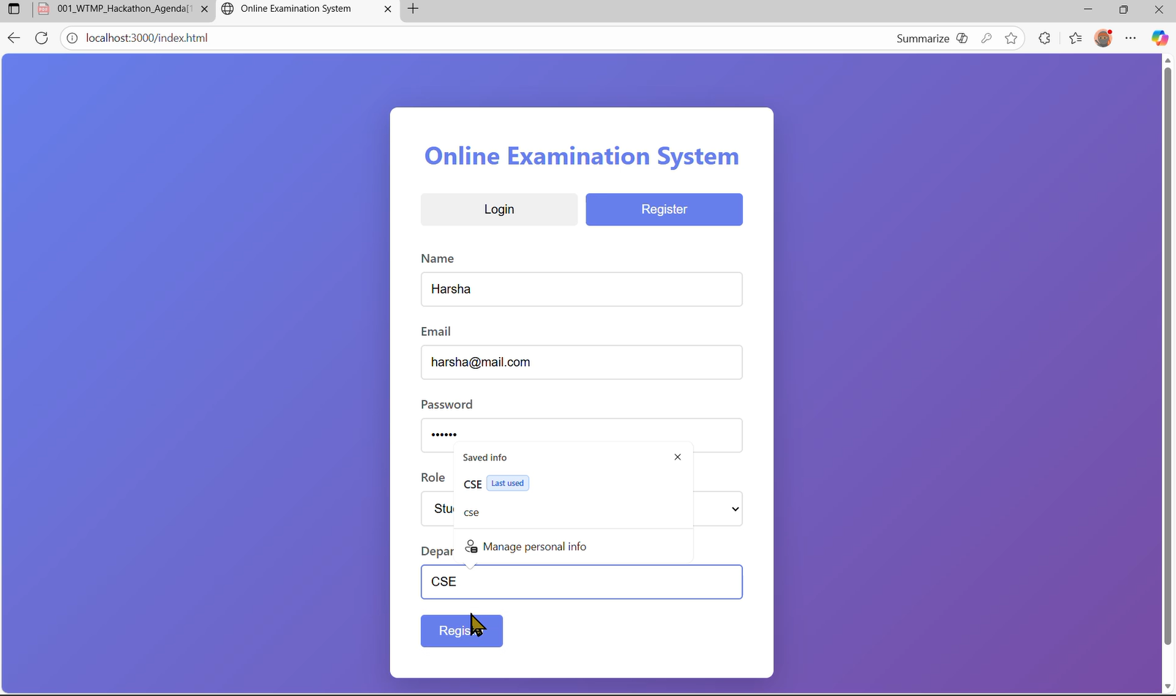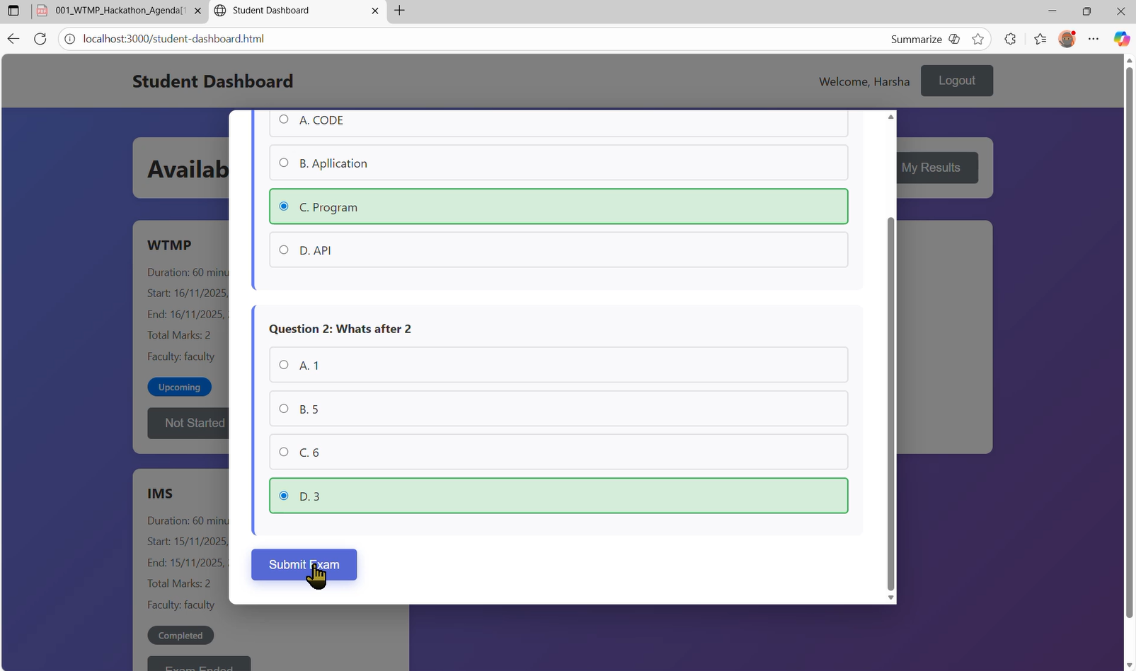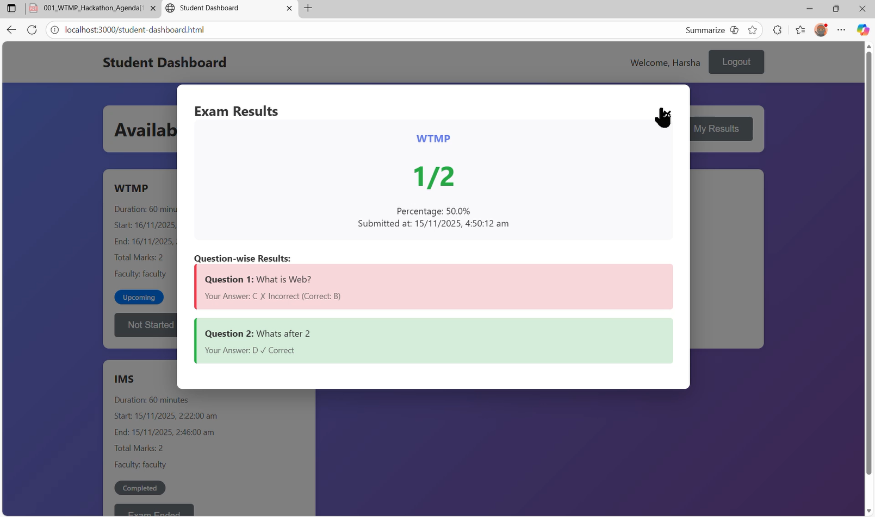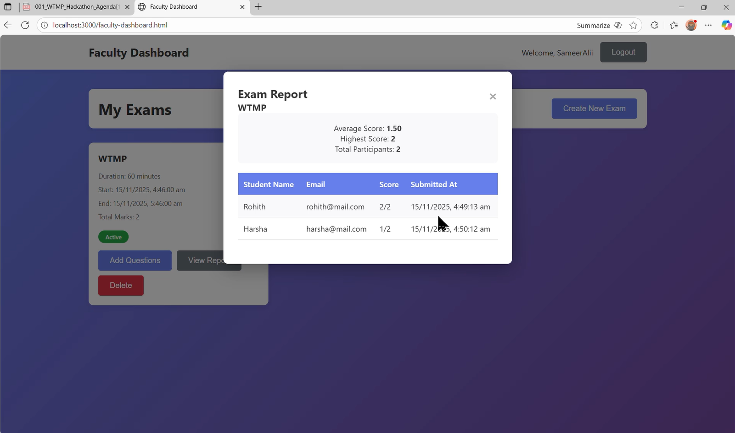

CONCLUSION
The Online Examination System successfully demonstrates how modern web technologies can automate and improve the examination process. By integrating secure authentication, timer-based exams, automated evaluation, and instant result generation, the system reduces manual effort and ensures transparency. It is cost-effective, scalable, and user-friendly, making it suitable for academic institutions and training programs. Beyond solving current challenges, the project provided valuable learning in full-stack development, database design, and security practices. With future enhancements such as subjective evaluation, proctoring tools, and mobile app support, the system can evolve into a comprehensive digital assessment platform.

REFERENCES
- Node.js Documentation
- MongoDB University
- Express.js Docs
- JWT Authentication Standards
- OWASP Security Guidelines
- Cloud Deployment Best Practices
- JMeter Load Testing Documentation
- WCAG Accessibility Standards

